**Pemrograman bash shell pada system operasi linux**

$ Lakukan perintah berikut: $

who

whoami

ls

mkdir testing

sudo su

mkdir testing

cd testing

touch index.js

ls

cd ..

ls

clear

rm –rf testing*

$ Langkah pemrograman shell: $

nano uji.sh

#!/bin/bash

echo “saya super admin”

^x

Y

ls

ls –l uji.sh

chmod +x uji.sh

./uji.sh

$ File sederhana $

nano uji2.sh

#!/bin/bash

#Program shell

#

var1=y

echo $var1

^x

y

chmod +x uji2.sh

./uji2.sh

$ shell interaktif 1 $

vpt=var1=Y

echo $vpt

$ shell interaktif 2 $

v1=2

v2=’+’

v3=5

v4=’=’

v5=7

v6=$v1$v2$v3$v4$v5

echo v6

$ Read string $

read jenis

pria

echo $jenis

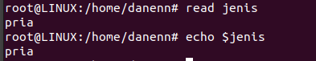

$ penjumlahan aritmatik $

nano aritmatik.sh



#!/bin/bash

a=17

b=3

let result=$a+$b;

echo “$result”

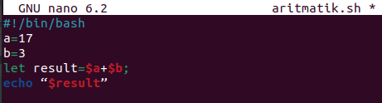

^x

Y

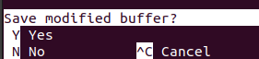

chmod +x aritmatik.sh



./aritmatik.sh



$ .js $

nano code.js



const data = “saya super admin”

console.log(data);

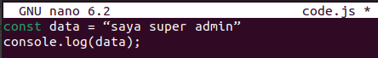

^x

Y



cat code.js



node code.js



$ Install $

a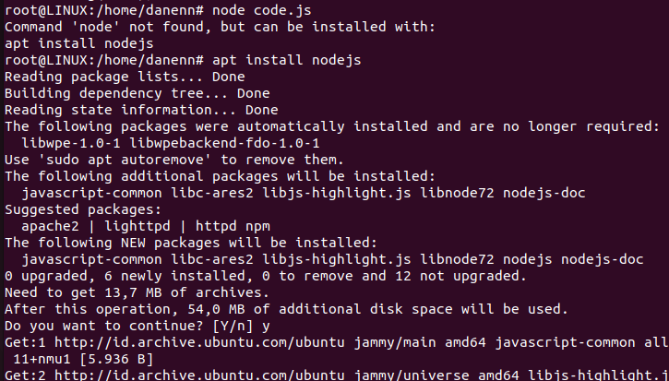pt install nodejs

apt update

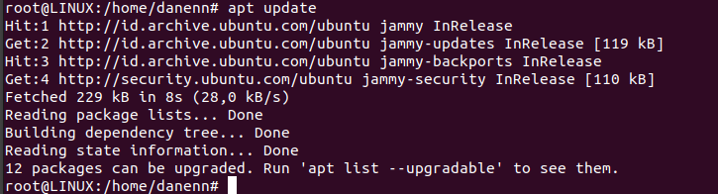

apt upgrade

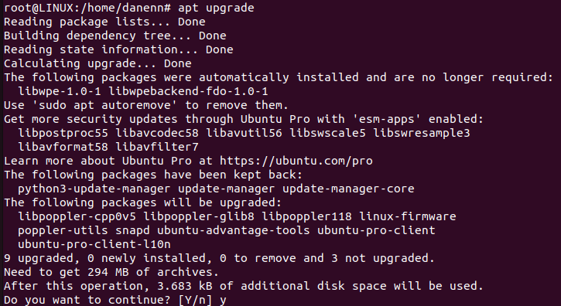

node code.js

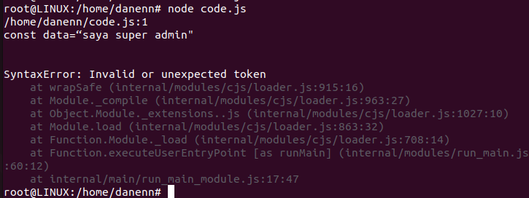

$ World wide web and get http https (wget) $

wget <https://drive.google.com/file/d/1kQwK1fjfbBkC4WQKhOmv4IiJ3b22i3D_/view?usp=drive_link>

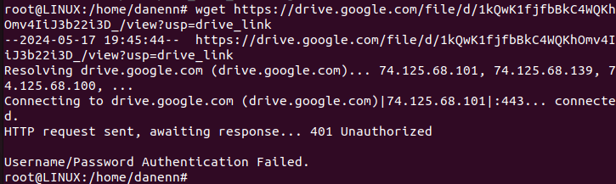

http://192.168.73.195/File-SisOp.zip



sudo apt install wget

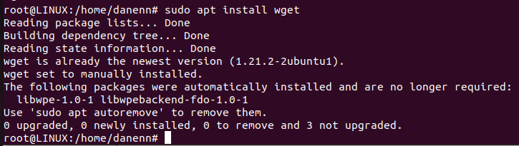

$ Condition shell pada linux $



#!/bin/bash

tmer=10

while [ $tmer –gt 0 ]

do

echo “… $tmer”

tmer=$((tmer -1))

sleep 10s

done

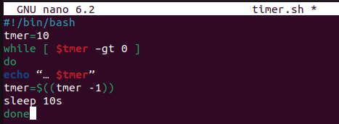

$ Pemrograman condition shell $

clear



echo “Stok barang hari ini”;

echo “…………………………….”;

echo “1. beras”;

echo “2. gula”;

echo “3. Garam”;

echo “4.exit”;

read –p *pilih barang keluar [1-4 ] :* pil;

if [ $pil –eq 1 ];

then

echo “ banyak barang = *;

read jum

let bayar=jum*10000;

elif [ $pil –eq 4 ];

then

exit 0

else

echo “Barang tidak tersedia”

exit 1

if

echo “harga bayar = Rp. $bayar”

echo “Terimakasih atas kunjungan anda”

echo “ Kantin TI”

nano kasir.sh



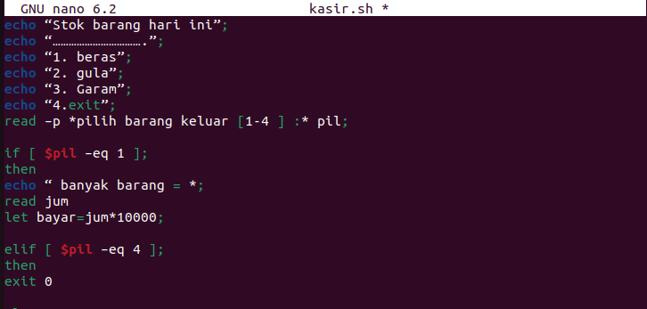

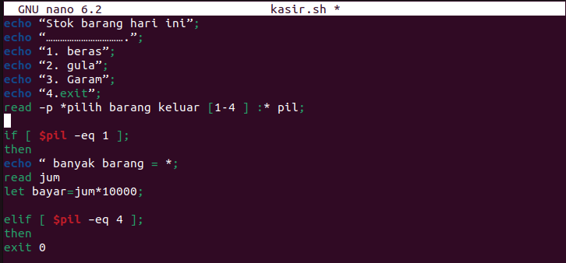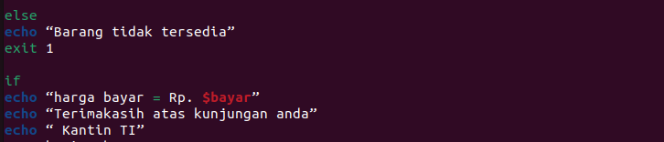

ls –l kasir.sh



chmod +x kasir.sh

ls –l kasir.sh

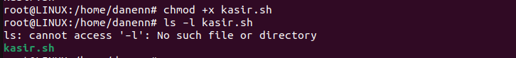

./kasir.sh

